**AIM:**

To implement the modified system and test it for various scenarios

**ERROR:**

Count of animals is not deceremented after clicking buy button.

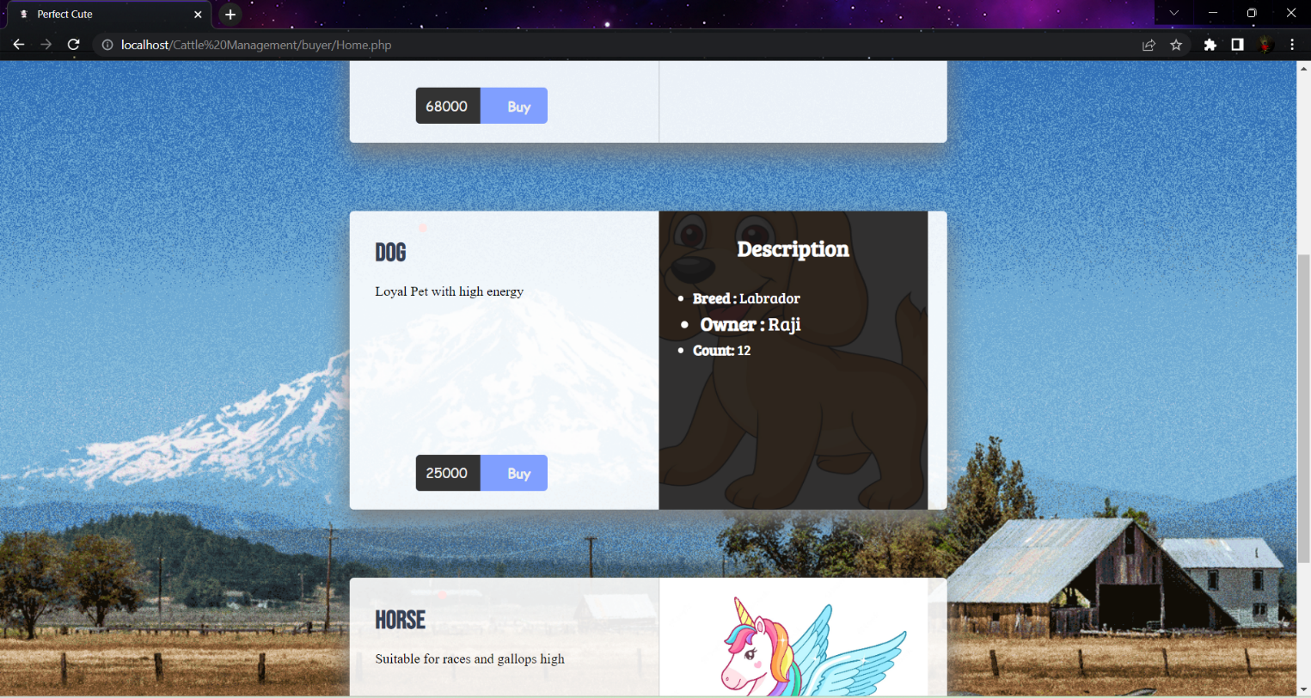

CORRECTED OUTPUT:

Before Clicking Buy:

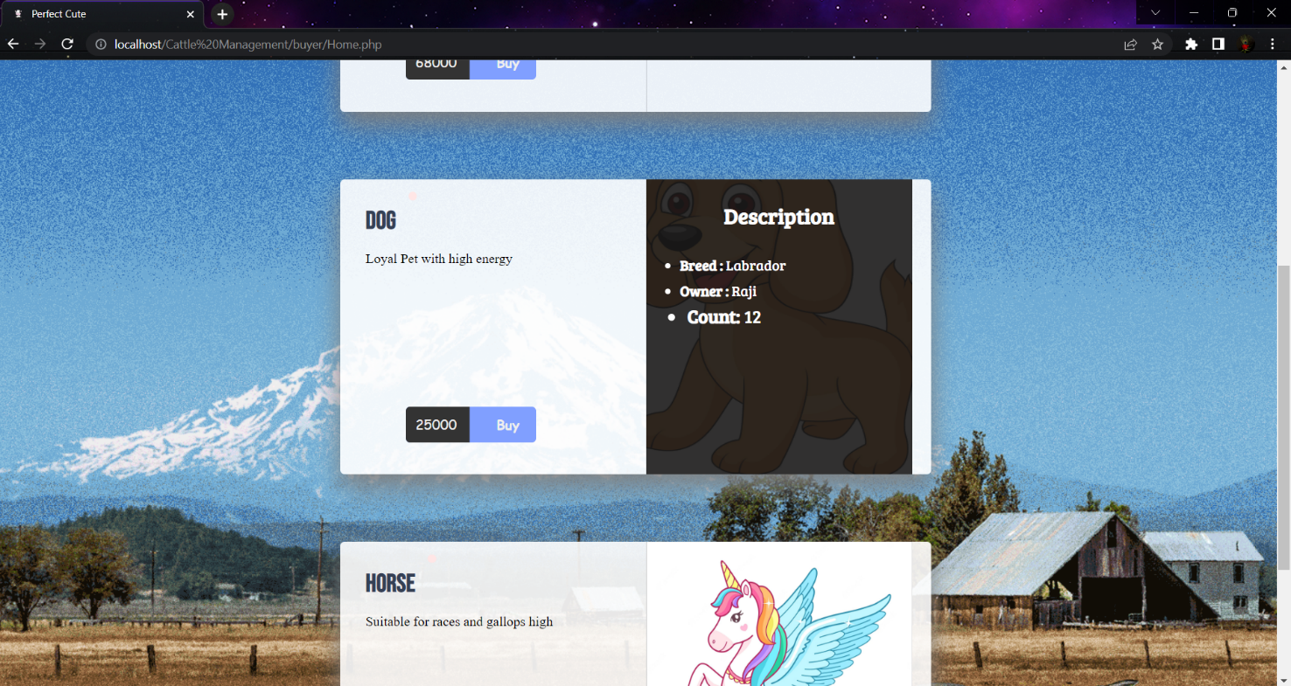

After clicking Buy:

